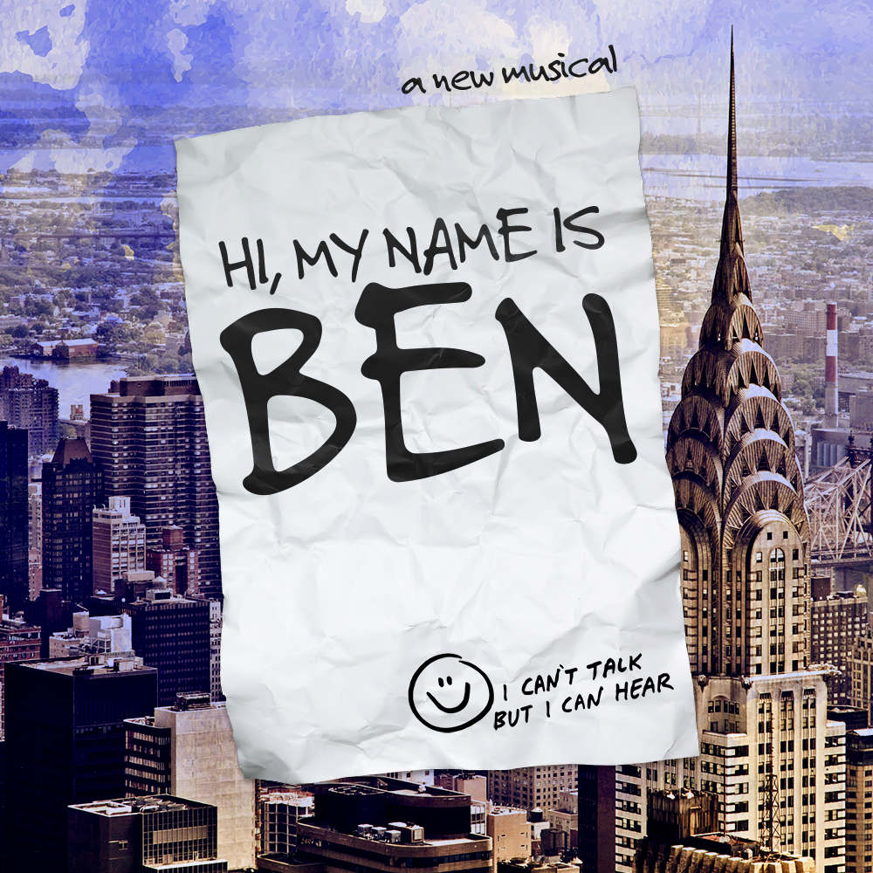­­­

**GOODSPEED MUSICALS PRESENTS**

***Fill in your group’s information below and print on legal size paper.***

**Your Organization Name**

**Performance Date, 00:00 PM**

$00.00

***Event Details:*** The true story of an ordinary man and his extraordinary life. From his tiny room in New York City, Bernhardt Wichmann III changed the lives of those around him without saying a word. Using just his notepad and pen and open heart, Ben turned a neighborhood of strangers into a community of friends. Featuring a joyful, folk-inflected score by an award-winning Scottish writing team in collaboration with Dundee Rep, one of Scotland’s leading theatres, this is the story of how one man with nothing somehow changed everything.

*Your Contact Info*